A POSITIVE EXPERIENCE

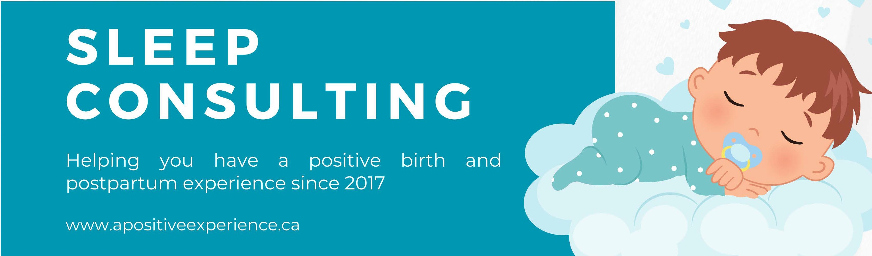

WHAT IS SLEEP CONSULTING?
Sleep consulting is the process of working with a trained consultant to evaluate children's sleep challenges, provide education on children's sleep and assist in implementing strategies to make improvements to it.

WHAT CAN WE EXPECT TO LE.ARN IN WORKIN<i WITH A SLEEP CONSULTANT?
Some of the most helpful education is relevant to how much sleep children need, how the circadian rhythm affects one's ability to fall asleep, and how behavioral psychology is a large part of sleep challenges.

WHAT IS EVALUATED IN THE TWO-HOUR CONSULTATION?
We will evaluate the key factors that affect baby/toddler sleep. These include but are not limited to: the sleep environment, sleep nutrition, ailments and illness, circadian rhythm, routine and consistency, reading sleep cues, the child's emotional needs and the parent's emotional needs, correctly addressing baby needs, and sleep aid dependence.
During the consultation we:
-Complete a full evaluation of your baby/toddler's sleep
-Discuss short-term goals that we wish to accomplish within the three weeks
-Discuss long-term goals that we hope to take place over a longer period of time
-Develop a plan using sleep training strategies to help achieve the goals

WHY IS THERE A THREE.­ WEEK FOLLOW-UP PERIOD?
The consultation is where we discuss and make a plan for how to achieve the sleep goals you have made, but it takes about three weeks to put the strategies in place and make the changes in sleep. We offer a three-week follow-up period since most of the strategies we prefer to use are more gradual, and gentle; therefore, often take longer to be put into place.
During the three-week follow-up period, we ask that you track your little one's sleep daily using the free "Rested" app so that we can review the progress, troubleshoot and make changes if needed.

THINGS WE CAN HELP WITH
- Frequent Night Waking
- Late Bedtimes
- Early Morning Waking
- Being awake for portions of the night
- Contact napping
- Short Naps
- Transition to Own Bed or Room
- Not enough sleep
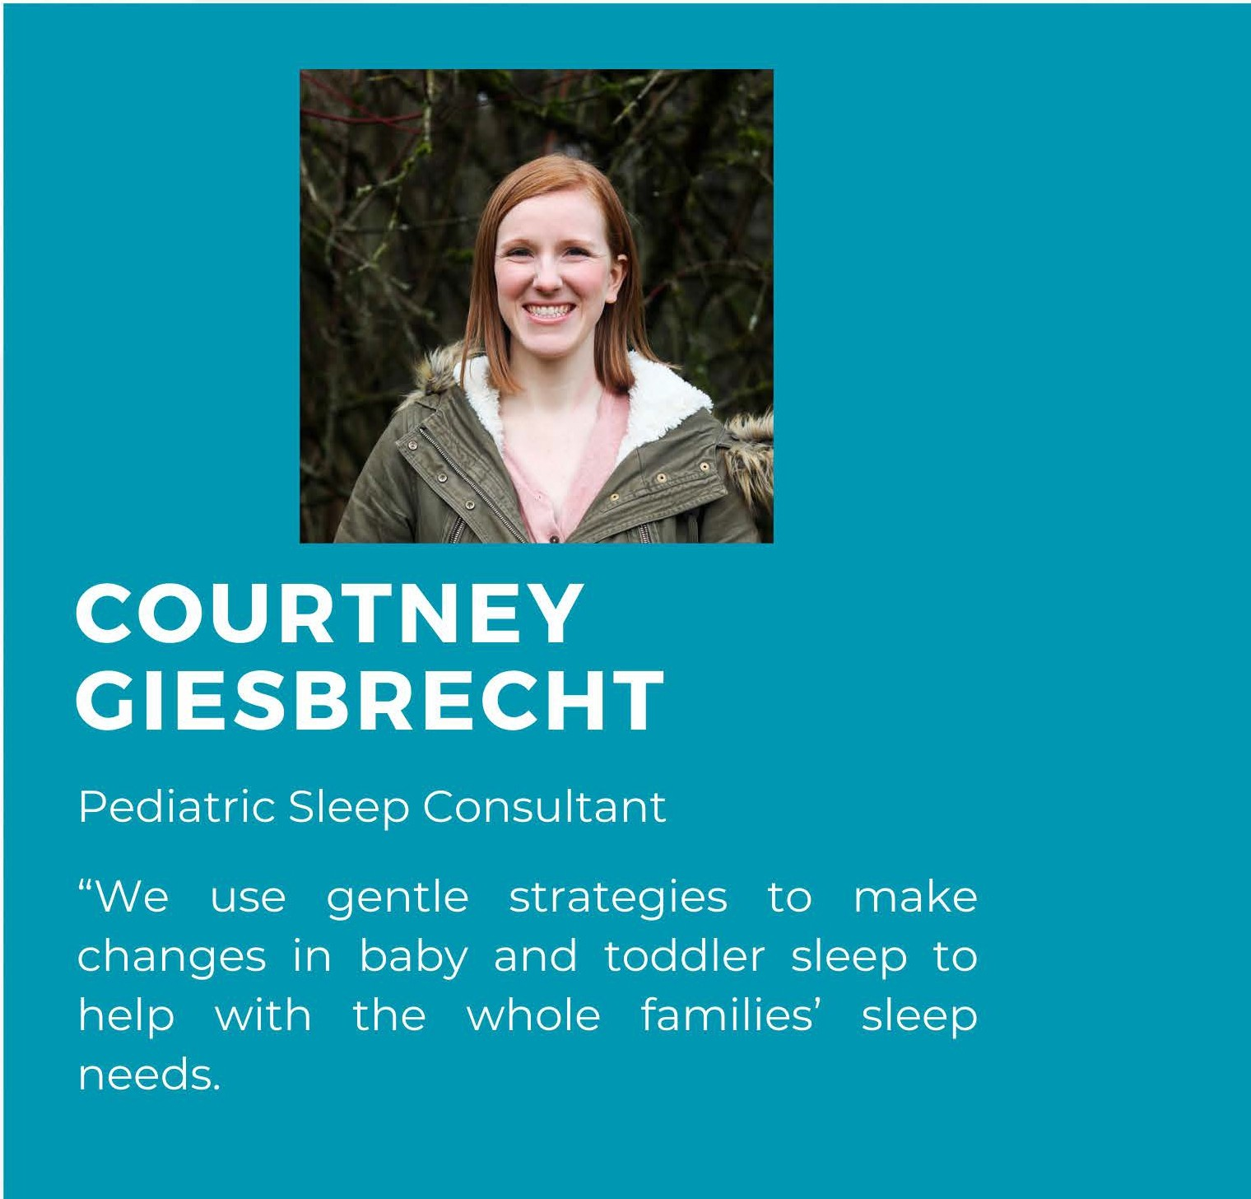
- Taking a long time to go down for nap or bed

